**20 Points**

# Directions

1. Complete the following steps.
2. Screenshot where directed.
3. Submit to Blackboard.

### See the effect of a transaction

1. Start SSMS and a new query window for Henry Books.
2. Type the following query and execute it.

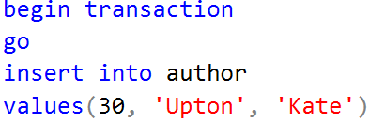

1. You have started a new transaction. The update made to the table is visible in this connection only.
2. Clear the query window. Run this query **Do not create a new window yet**. Kate Upton should be returned. Screenshot the output





1. You will now test the transaction lock. **Create a new query window**. Run the same select query from above. **It should freeze and display no data**. Screenshot the frozen query. When you get bored, click the button to stop the query. ⬛ This is because the update is not committed. The table is locked until the data is committed
   1. Screenshot the yellow bar at the bottom showing it executing.  
      
2. Switch back to the first query window. Undo your changes with the following command.



1. Switch to the second query window and run the select query again. Kate Upton is no longer in the database. Screenshot the lack of output.  
   

## More on the back side…Use Premiere for this side

### Create a transaction

You need to update the database. Reconfigure this query as **one transaction** so if either of the inserts fails, the entire operation fails and rollbacks.

Note, my code assumes that you added the lastChanged field. If you did not do this last week, then ignore the ending ,null field.

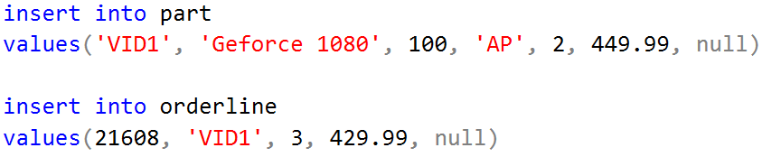

Screenshot the completed code.

### Create multiple transactions

You need to create parts. Configure the following query into **two transactions**. The two video cards as one transaction and the two CPUs as their own. Each transaction will succeed or fail on its own. If a transaction fails it should rollback and display an error message.

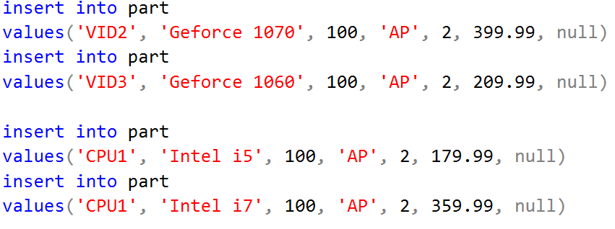

Screenshot the completed code

